User Documentation

Web Scraper

User Documentation


Filtering

Filtering (Genre, Text, And stock):
Filtering for a specific book is quite simple 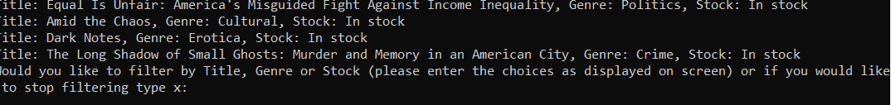
Just type in title,genre or stock and press enter

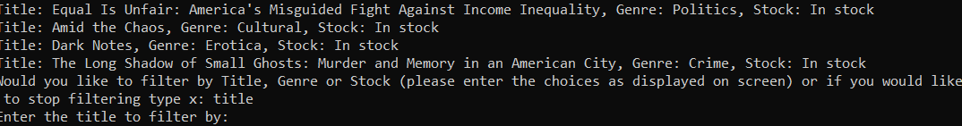
Then enter what you want to filter by
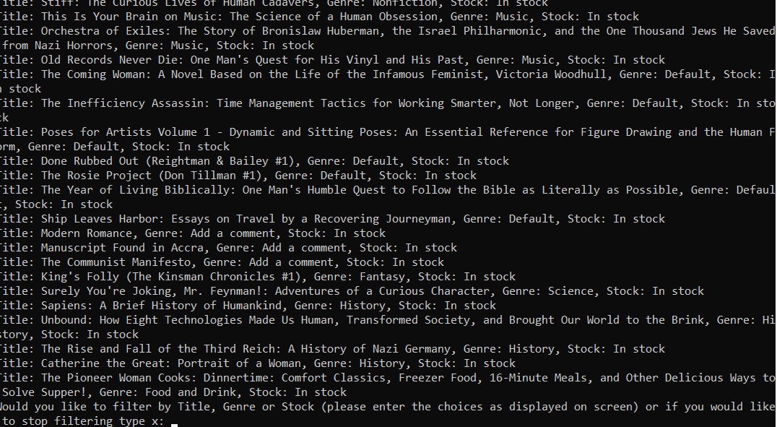
For example i typed in “Man” and got this result

Product Rationale

Product Rationale

in this project we want to be able to search for a book genre then search for a specific book to see if its in that genre and if its in stock. for this we will need all the books titles, genres and if they are currently in stock.

Common Questions

Common questions

- Why does the program take long to scrape websites:
This is because it has to go through every genre and store them and it will only redo it when the program is closed out.

- Can i use this program for different websites?:
No as this program was specifically designed for the book scraper website.

